34.100: The first image formed by the spherical mirror is the one where the light immediately strikes its surface, without bouncing from the plane mirror.
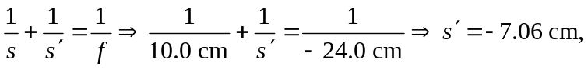and the image height:
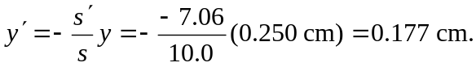
The second image is of the plane mirror image, located 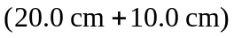 from the vertex of the spherical mirror. So:
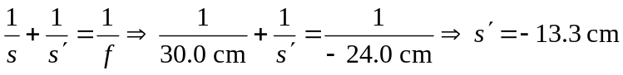 and the image height.
